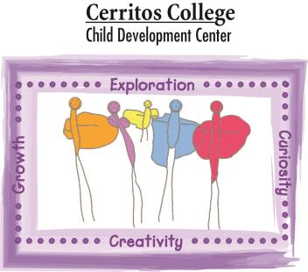
Cerritos College Child Development Center
Holiday and Teacher-IN Service School Calendar
Fiscal Year 2019-2020
Observed Holidays
- Independence Day:
Thursday, July 4, 2019 and Friday, July 5, 2019

- Labor Day:
Monday, September 2, 2019

- Veterans Day:
Monday, November 11, 2019

- Thanksgiving Day:
Thursday, November 28, 2019 and Friday, November 29, 2019

- Winter Holiday Break:
Monday, December 23 thorugh January 3, 2020

- Martin Luther King JR:
Monday, January 20, 2020

- Presidents Day:
Friday, February 14, 2020 and Monday, February 17, 2020

- Memorial Day:
Monday, May 25, 2020

Teacher-In Service
- Friday: August 9, 2019
- Friday: October 25, 2019
- Friday: January 17, 2020
- Friday: May, Friday 22, 2020

