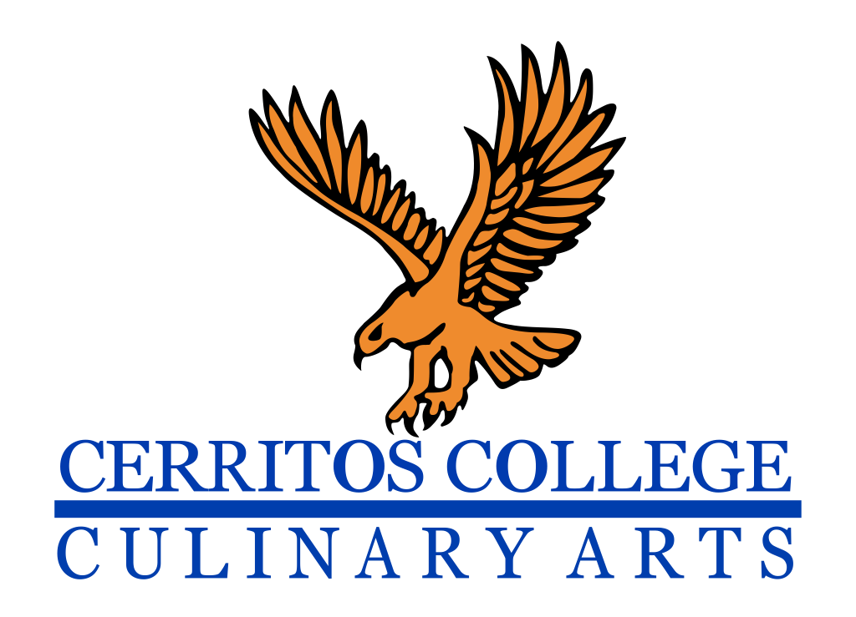
Falcon Room Restaurant
Beverages
Iced Tea, Green Iced Tea, Pepsi, Diet Pepsi, Sierra Mist $2.00
Apffel's Coffee: pour-over, Expresso, Cappuccino, Latte $3.50

Appetizers
Caesar Salad Crostini, Parmesan Crisp and Classic Dressing $4.00
Daily Roasted Vegetable Special $4.00
Mushroom Toast with Brioche and Béchamel Sauce $4.00
Soup Du Jour $3.50

Entrees
Roasted Beet Salad $7.00
Arugula Lettuce, Goat Cheese, Strawberry Vinaigrette and pecan crisp

Grilled Salmon Caesar Salad $7.50
with Crostini, Parmesan Crisp and Classic Dressing

Wild Forest Mushroom over Fresh Pappardelle Pasta $7.00
Add Chicken Breast + $1.50

Fresh Tomato, Basil, Garlic Sauce over Fresh Pappardelle Pasta $7.00
Add Chicken Breast + $1.50

Pan Seared Salmon
Braised Fennel, Rice Pilaf, Garden Vegetables and Buerre Blanc $8.75

Bento Box $8.50 Katsu with Curry Sauce Tempura Vegetables, Spicy Slaw and Rice

Grilled Top Sirloin Steak 6oz $9.25
Polenta, Farm Fresh Vegetables and Fried Potato Crisp

Desserts
Variety of Daily Creme Brûlée $3.00

