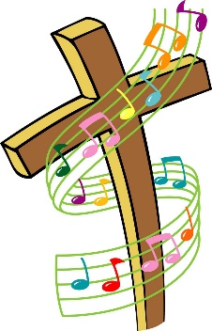

My Life
My Eyes
My Ears
My Heart
Reckless Love

