Troubleshooting Cerritos WPA Wi-Fi on Devices
This guide is to assist with issues connecting to the Cerritos WPA wireless network. A common issue when connecting to Wi-Fi is when a device has an outdated ‘stale’ password stored onto the device causing it to attempt to connect to Wi-Fi and failing. You may see a message stating “cannot connect to this network” or “failed to connect to the network”. This may also cause your Cerritos account to get locked out from the network as it attempts to and fails to authenticate.
Here is how you can “Forget” the last saved cached wireless information on your device and re-attempt to authenticate to the Cerritos WPA:
Windows 11:
- When attempting to connect, you may see an error stating that you can’t connect to the network.
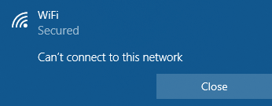
- On the bottom right corner, click on the Wi-Fi symbol to open the Wi-Fi selection screen and then click on the right arrow to show all the Wi-Fi connections and then right click on Cerritos WPA network and click on “Forget this Network” option:
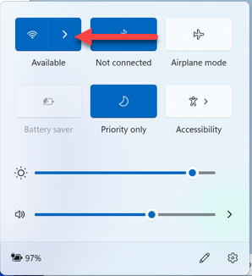
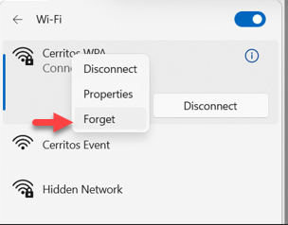
- Once completed, reattempt to connect to the Cerritos WPA and then enter your current Cerritos username (or Student ID) and password and click on the “OK” button.
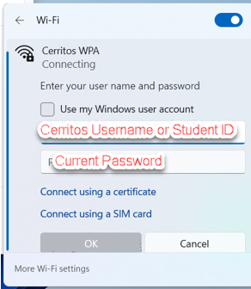
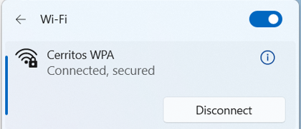

MacOS 15 Sequoia:
- On your mac, click on the apple symbol on the top left corner of your menu bar and click on System Settings:
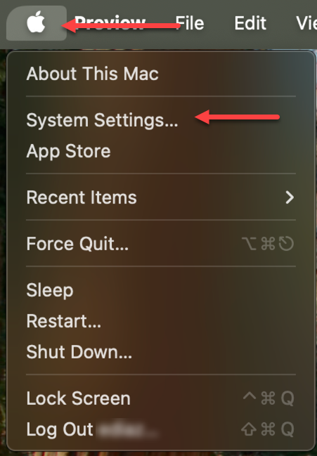

- On the Wi-Fi menu tab window, go to the section under Known Networks and then click on the small button with 3 ellipses dots and then on the menu that opens click on “Forget this network”

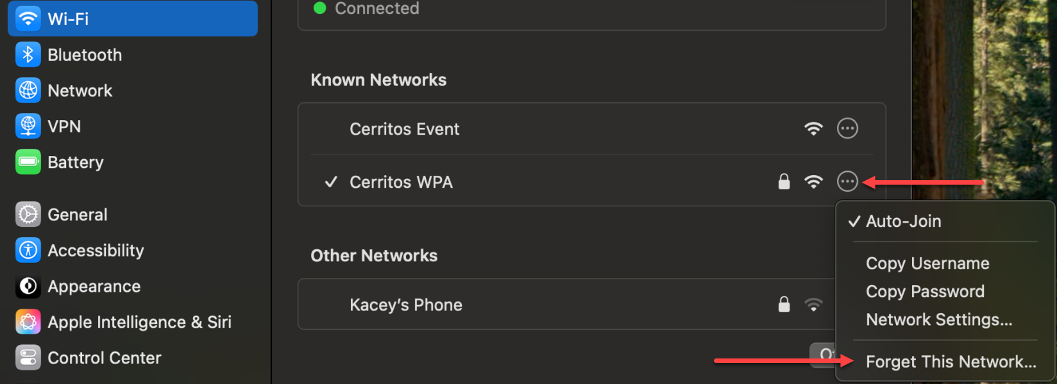

- Confirm the removal of the Cerritos WPA connection (this will remove any stored passwords for the Cerritos WPA connection on your Mac)
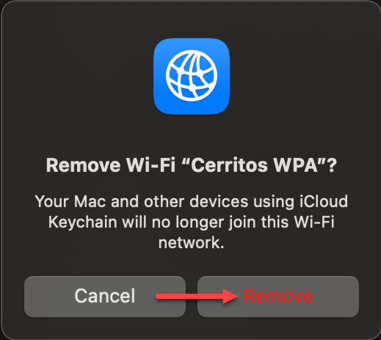

- Once it has been removed, retry connecting to Cerritos WPA using your current Cerritos Username (or student ID) and Password.
