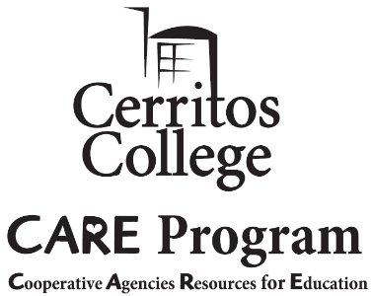
Cerritos College CAREs
2018-2019 NEWSLETTER

INSIDE
THIS
ISSUE

PG. 2
The Year in Review
Journey with us through a year of community-building, growth, and celebration.
PG. 3
Scholarship Spotlight
Demonstrating excellence, CARE students awarded more than $16,000 in scholarships.
SPICE Club
Supporting Parents in College Education Club Relaunched.
PG. 4
Student Success
CARE students overcome the challenges of single parenting, working, and college to achieve academic goals!
IF YOU ARE A
Parent,
YOU ARE A
Superhero,
PERIOD.

“Smart Money Smart Kids” Book Club Coffee, Tea, and Conversation

CARE Coordinator’s Corner
Welcome to our annual edition of Cerritos College CAREs, a publication highlighting the Cooperative Agencies Resources for Education (CARE). The CARE program is designed to support the academic success of single, head-of-household parents receiving TANF/CalWORKs assistance, leading to accomplishment of higher education goals, sustainable employment, and self-sufficiency. Resources aim to increase retention, graduation, and transfer rates through unique above-and-beyond services including mentorship, guidance, specialized workshops, supplemental grants (childcare, transportation, meals, supplies, etc.), and events to support family-unit success.

Coming on board this past August as the new CARE Coordinator, I am honored to continue the tradition of excellence set by Ms. Marcia Chaney. We thank her for championing student success for over 30 years, and wish her well in retirement!

I am excited to pair my 20+ years of experience at the federal/state/local-level, and private sector project management, workforce development, training, and business administration with student support services. Since joining Cerritos College in 2015, I have had the privilege to be mentored through positions in Public Affairs, and the Foundation offices. Both provided great insight to resources across campus, and opportunity to collaborate with staff, faculty, and donors. I am grateful to have the space to bring all this together to best serve students!

This year has been the most fulfilling time, and simply put, I LOVE my job and students! I am so thankful to all who have partnered with us to make magic happen, and look forward to collaborating again to bring bigger and better things to fruition! Please enjoy our newsletter!

All my best always,
Stephanie Minami, CARE Coordinator

“Your work is going to fill a large part of your life, and the only way to be truly satisfied is to do what you believe is great work. And the only way to do great work is to love what you do.” ~ Steve Jobs

The Year In Review

Events throughout the year provided the opportunity to build community, grow, and celebrate. It was truly fascinating to see first-hand the dynamics, relationships, love, and support evolve among students!

Fall Semester
Holiday Celebration
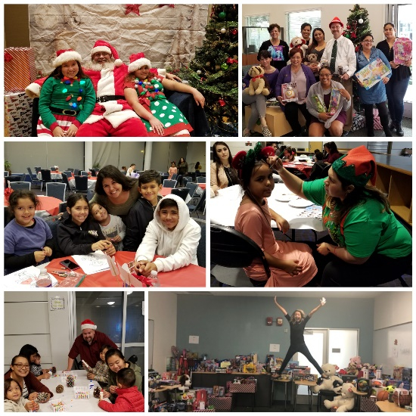
- Scholarship Workshops held to assist students complete applications, with 1:1 sessions to finalize personal statements, and prepare for interviews.
- Thanksgiving Turkeys for 18 families experiencing food insecurity, offered through the support of Financial Aid.
- Holiday Celebration attended by 80 CARE, CalWORKs, LINC, and Veteran families who enjoyed music, food, crafts, face painting, and photos with Santa. Through the enormous outpouring of support and generous donations by our campus community, over 260 children received toys!!!

Spring Semester
- Welcome Back Pancake Breakfast prepared by CARE and LINC staff to help students jump start the new semester.
- “Smart Money Smart Kids” Book Club runs through summer, providing 24 students with online & in-person participation options to learn tools to equip their children for financial success, saving, investing, and living debt-free.
Spring Family Picnic
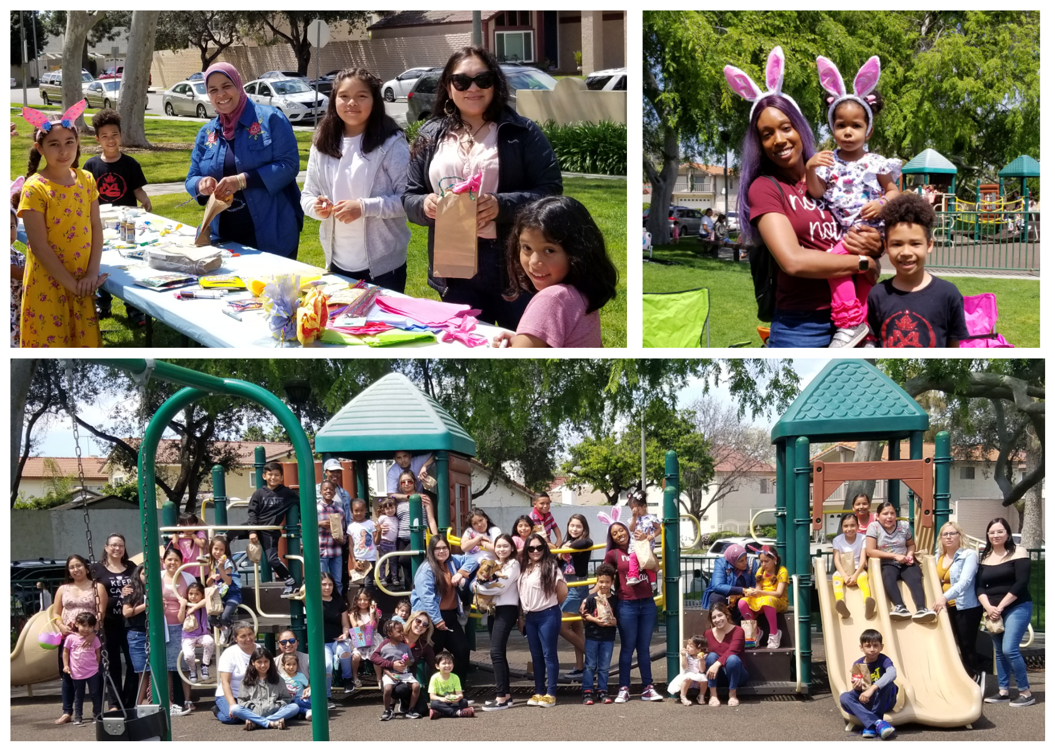

- Spring Family Picnic, in collaboration with LINC, with over 60 attendees enjoying games, egg hunt, crafts, food, and prizes under the sun at a local park.
- Paint Nite provided parents with an evening out, using art as a medium for self-care. Students who were unable to attend received a gift kit with canvas, paint, brushes, and screen-printed “Parents are Superheroes” apron. We are grateful for the support of ASCC funding for this event.
- CARE Conference held at the Knott’s Berry Farm Hotel, bringing together students from 14 campuses locally, providing opportunity to network, gain insight from motivational speakers and workshops, and win raffle prizes.
- Parents are Superheroes Celebration (story on page 4)

SPICE Club

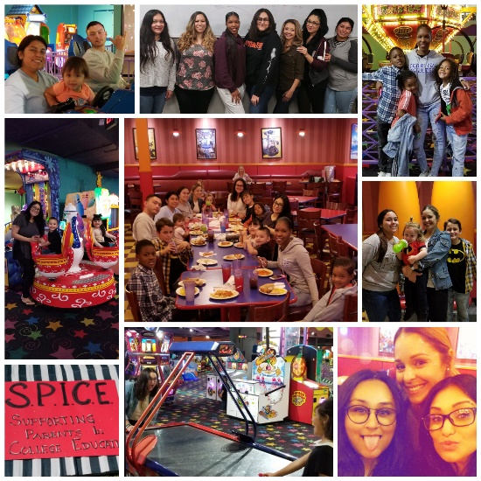
The “Supporting Parents in College Education” (SPICE) Club was relaunched with 14 members, and aims to create space for community for students on a shared journey. The club provides opportunity to support, empower, and promote student and family-unit success through networking, meetings, and family events. Members raised funds for a family movie night in the fall semester, and a pizza game night in the spring semester, building impactful relationships along the way.

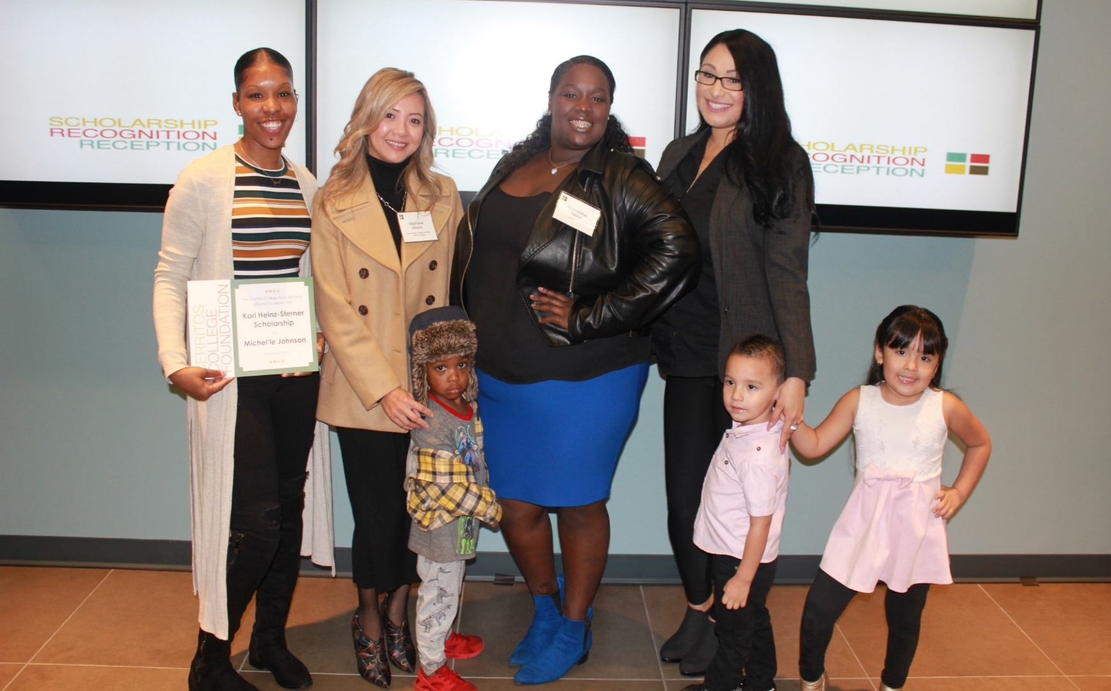
CARE students overcame the challenges of single-parenthood, work, college coursework, and financial hardship to demonstrate academic excellence. Congratulations super parents for securing more than $16,000 in scholarships!

We are thankful to the Cerritos College Foundation, donors, organizations, and service groups for making possible the following scholarships:
CARE students awarded more than $16,000 in scholarships
- Hemat Aly – CCCEOPSA Scholarship
- Jesus Ayala – Darlene Gomez Memorial Scholarship
- Gisselle Bernal – Cheryl Epple Memorial Scholarship
- Gisselle Bernal – CARE Regions VIII Scholarship
- Gisselle Bernal – Chaney Family Scholarship
- Michel’le Johnson – Ellen Carver Scholarship
- Michel’le Johnson – Karl Heinz-Sterner Scholarship
- Suleyma Martinez – Artesia/Cerritos Women’s Club Scholarship
- Suleyma Martinez – Norwalk Women’s Club Scholarship
- Danyella Outler – Bernard Osher Scholarship
- Shaunise Price – Clara Harper “Well Done” Scholarship
- Shaunise Price – CARE Region VIII Scholarship
- Quannisha Taylor – Karl Heinz-Sterner Scholarship

Soroptimist International “Live Your Dream” Scholarship:
- Maria Alvarez
Scholarship Spotlight
- Alejandra Barcelos
- Rachel De La Rosa
- Camilla Idrees
- Michel’le Johnson
- Francisca Lezama
- Sarah Machai
- Shaunise Price
Celebrating Student Success

“Parents are Superheroes” Celebration Luncheon
CARE students are resilient, determined, strong, and committed to providing a better future for their families. They are NOT the average college student. In addition to college coursework, they balance the demands of single-parenthood, work, and financial hardship. Many have persevered through life’s most difficult circumstances, survived domestic violence, overcame homelessness, and continue to grapple with food and housing insecurity, a lack of transportation and support system, and a wide array of challenges which the conventional college student is not required to address daily.
CARE students’ accomplishments are a feat to be recognized, and honored. Lots of laughter, love, fun, and games were had during the “Parents are Superheroes” luncheon. Students celebrated each other’s academic, personal, and professional accomplishments, shared superhero life-hacks, and enjoyed Vietnamese cuisine, many for the first time.
Academic Success
Congratulations to students who were enrolled full time and maintained a cumulative GPA of 3.0 or higher:

- Hemat Aly
- Petra Amador
- Suraia Ashraf
- Jesus Ayala
- Gisselle Bernal
- Giselle Fernandez
- Monica Iniguez
- Michel’le Johnson
- Lourdes Lopez
- Sarah Machai
- Suleyma Martinez
- Elle Neri
- Shaunise Price
- Sunny Saldana
- Lisa Suarez

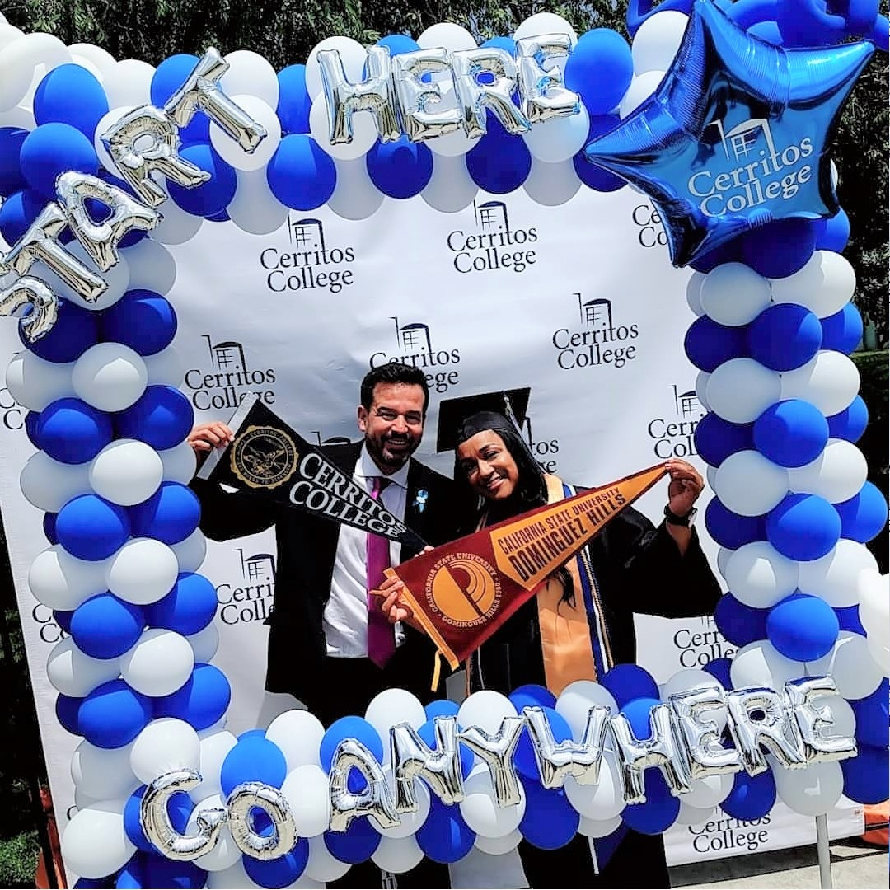
Congratulations Class of 2019 Graduates!!!
Start here, go anywhere! Congratulations to CARE students who have completed their education goals, earning multiple degrees and certificates, and transferring to university, or transitioning to full-time employment. We are so proud of your accomplishments!

- Sandy Arriaga
- Gisselle Bernal
- Suleyma Martinez
- Alma Torres
- Priscilla Torres

Stephanie Minami, CARE Coordinator
sminami@cerritos.edu | (562) 860-2451, Ext. 2384
11110 Alondra Blvd., Norwalk, CA 90650 | www.cerritos.edu/eops/care

