Supporting Figures, Charts, or Documents
Instructions: Attach all charts, graphs, and visual data that support your program review narrative in the corresponding section below. Every figure must be referenced in the narrative of your program review. Use phrasing like:
- “As shown in Figure 2…”
- “Figure 3 illustrates…”

Each figure must include the following:
- Figure #
  - Each figure should only have one unique number
  - Use consistent numbering throughout the report
- Figure title
  - Include what the figure represents
  - Include the timeframe in parentheses
- Data Source: Description of where the image/data originates from at the bottom of the image (e.g. Unit and Planning Dashboard, Dental Hygiene Graduate Survey)

Example figure:
Figure 1. Cerritos College and Math Department Headcount Comparison (2019-2025)
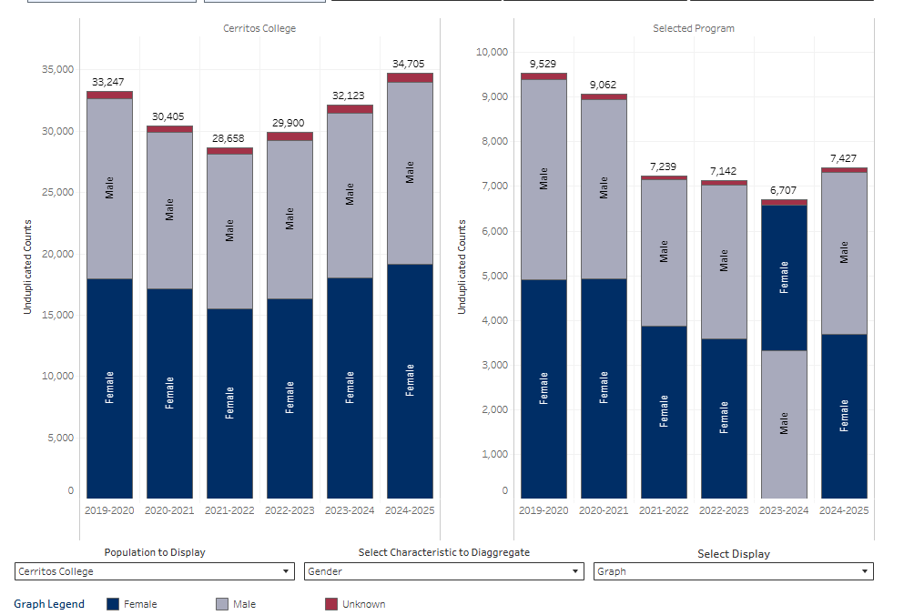
Source: IERPG Unit Planning & Program Review 2.0 Dashboard

Section 1: Non-Instructional Area Overview
Insert supporting documentation Section 1 below.

Section 2: Non-Instructional Area Trends
Insert supporting documentation Section 2 below.

Section 3: Non-Instructional Area Performance and Effectiveness
Insert supporting documentation Section 3 below.

Section 4: Previous Six-Year Non-Instructional Program Plan Reflection
Insert supporting documentation Section 4 below.

Section 5: Non-Instructional Area Three-Year Action Plan (Goals, AUOs, Objectives, Action Plans, and Resource Requests)
Insert supporting documentation Section 5 below.

Section 6: Non-Instructional Program Review Process Reflection
Insert supporting documentation Section 6 below.

