How to Find Funds on Morningstar
1. Go to: www.morningstar.com
2. Sign in

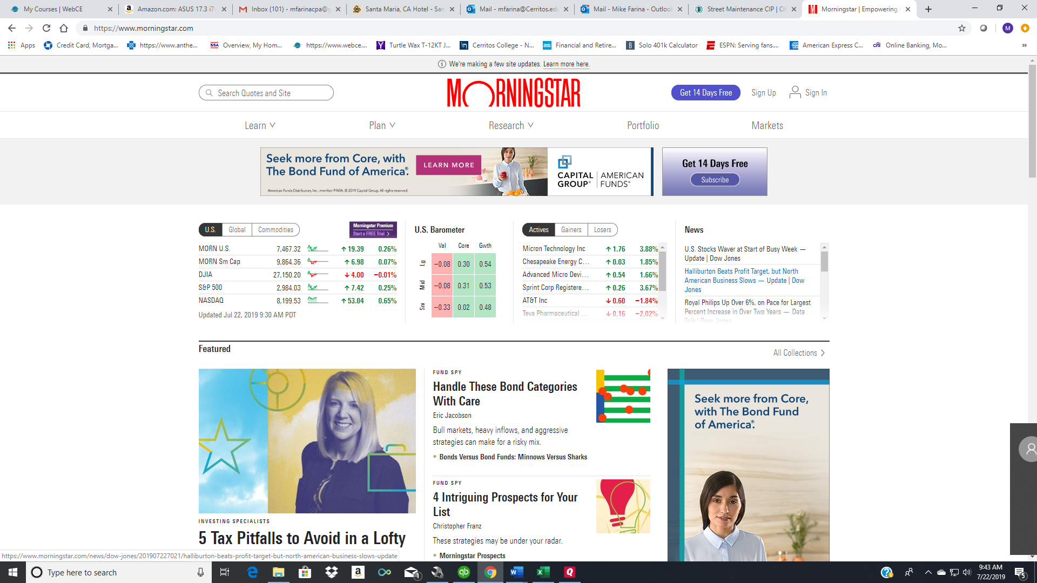

3. Select Research
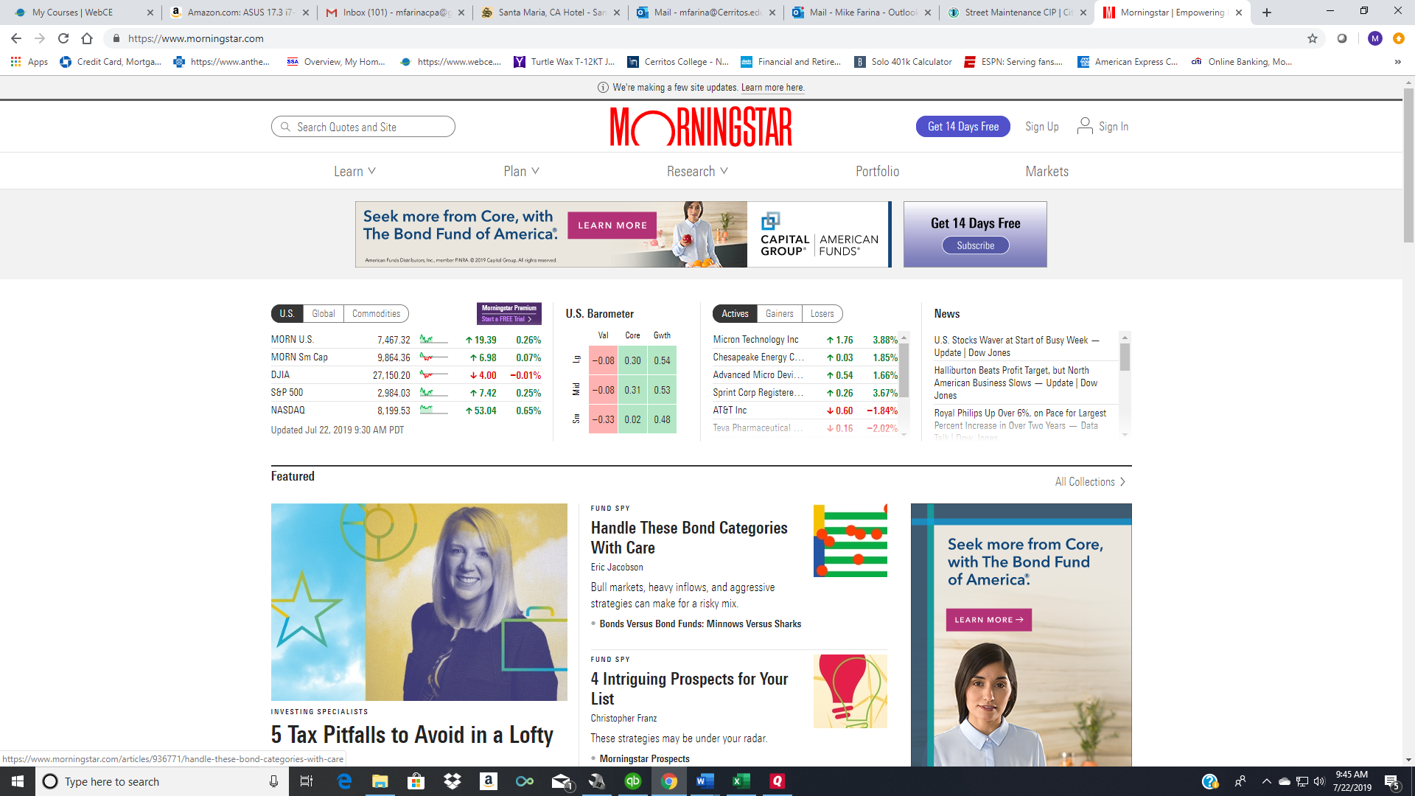
4. Select Mutual Funds
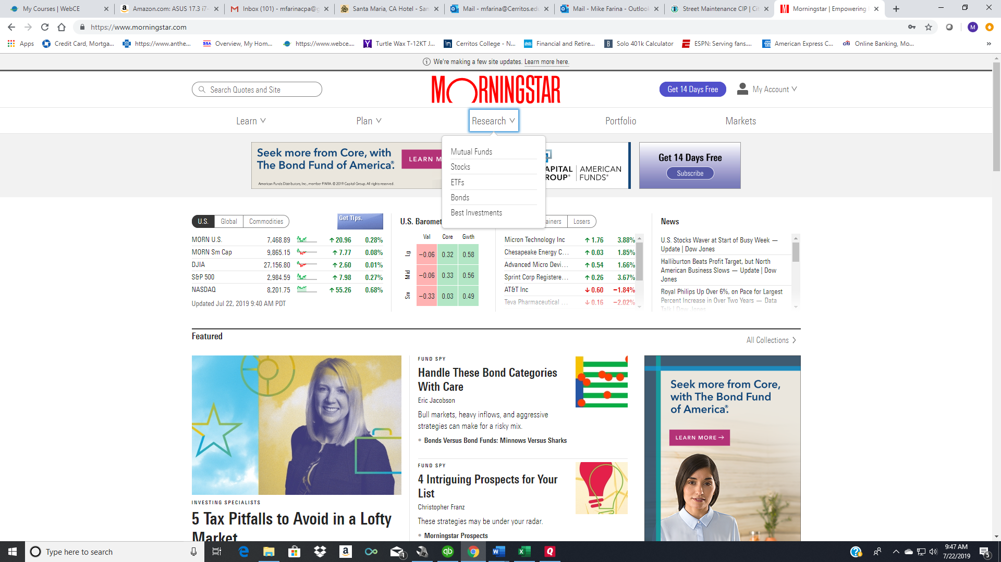
5. Select Basic Fund Screener

6. Make sure the “Set Criteria” tab is selected.

This is where you choose a criteria base on your investment planning. In Step 7, I will set the criteria as an example.

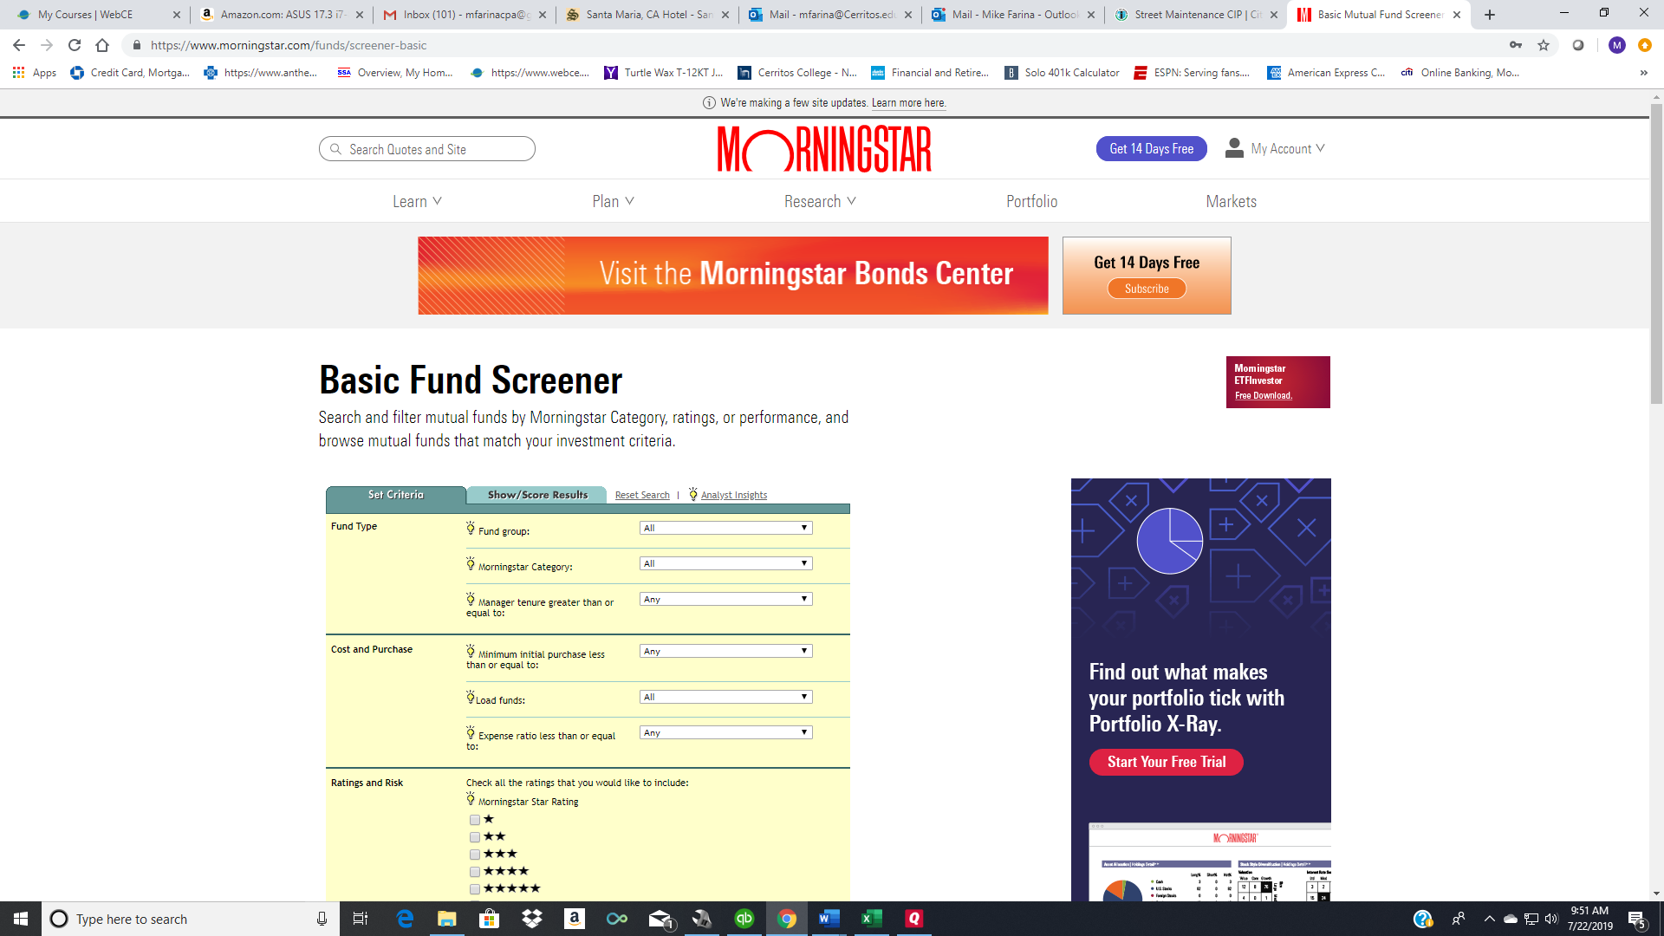

7. To set your criteria, click on the drop-down and choose from the given options. Here is my example:
Morningstar Criteria My Criteria Choices
Fund type Fund group: U.S. Equity
Morningstar category: Large Value
Manager tenure greater than or equal to: 3 Years
Cost and Purchase Minimum initial purchase less than or equal to: $1,000
Load Funds: No-load funds only
Expense ratio less than or equal to: 1.50%

Ratings and Risk Morningstar Star Rating Check both 4 and 5 stars

8. Scroll to the bottom and click “Show Results.”
This is what you will see after clicking “Results.” Make sure “Snapshot” is selected.
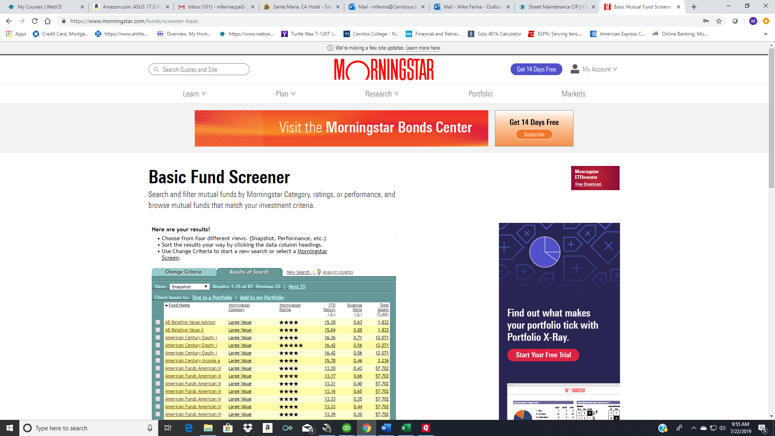

Select funds that appeal to you. You may also re-order the funds listed by clicking on the column called “Expense Ratio.” This will order the funds from lowest expense ratio to highest. You may also re-order the funds listed by clicking on “Morningstar Rating.” This will then re-order the funds, listing five-star funds first, followed by four-star funds.

9. Choose on a fund name that interests you. As an example, if I choose Putnam Equity Income Y (not pictured in #8 above), here is what I will see:
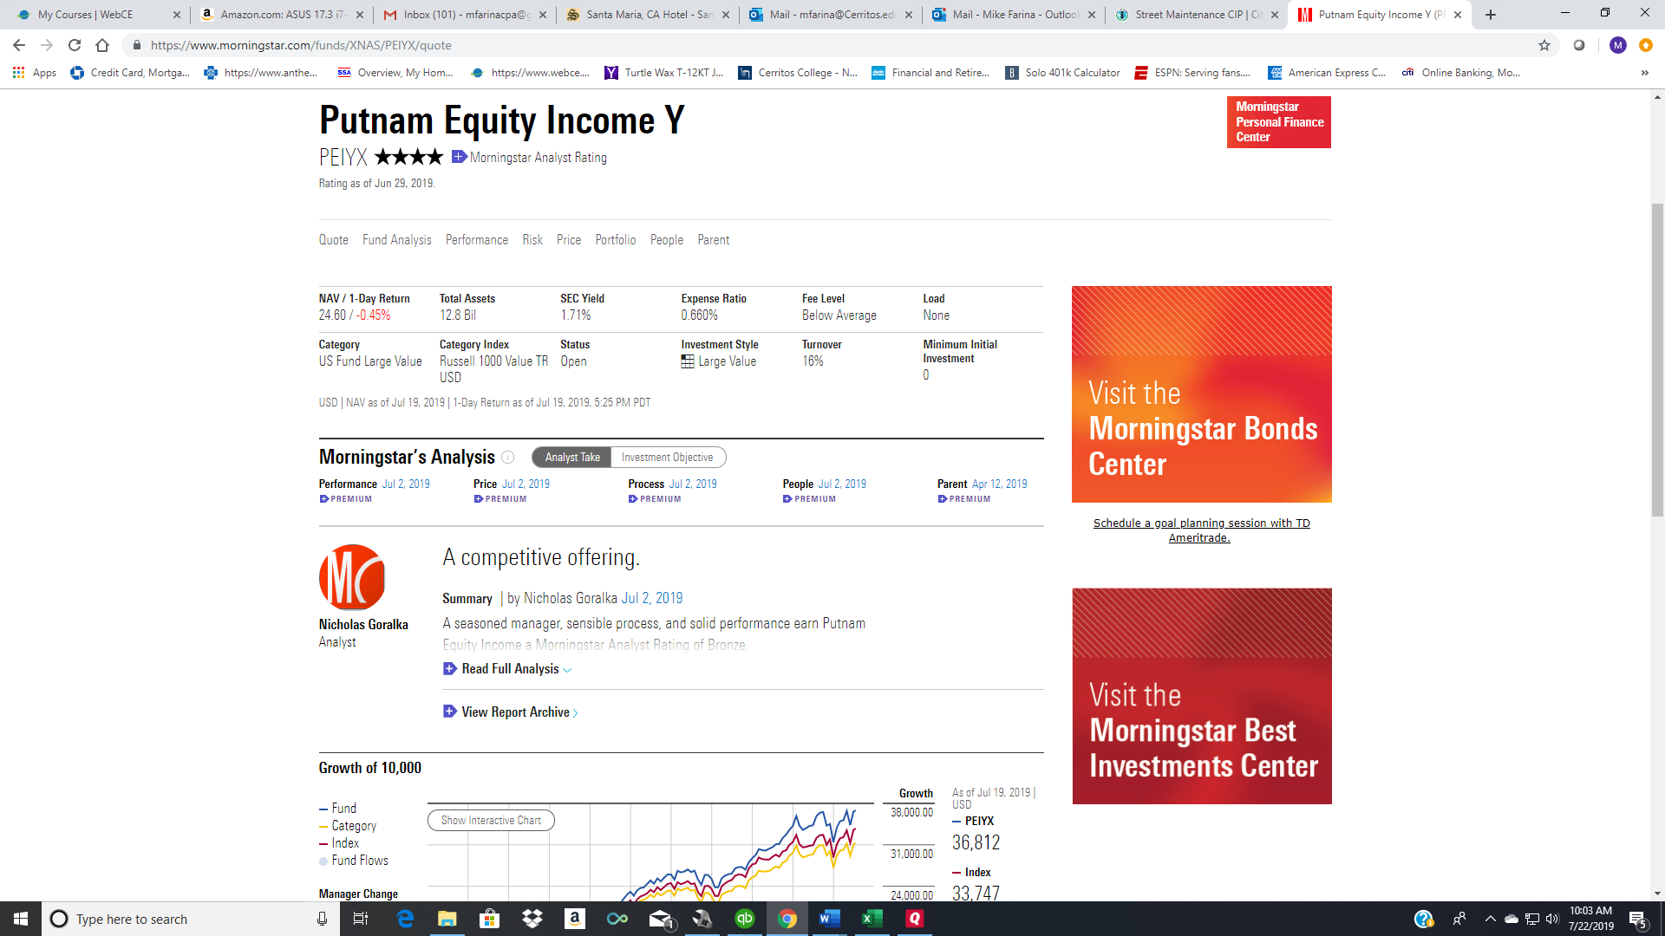

10. If you don’t like this fund, go back and choose another to research. If you do like this fund, write down the following for the project:
a. Fund name b. Category c. Expenses. This is the expense ratio.

